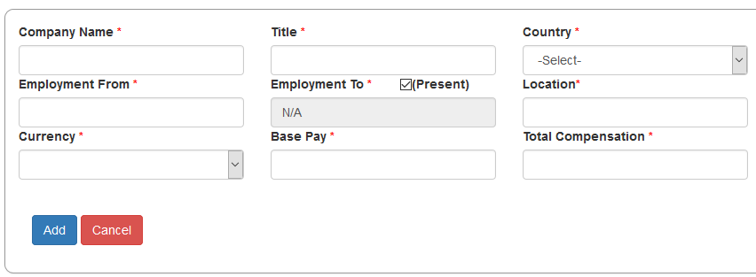

When 'Present' check box is selected that 'Employment To' is automatically populated with N/A